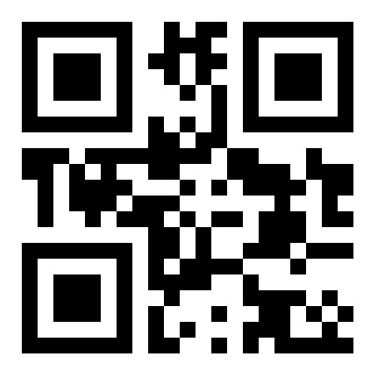Add text here.